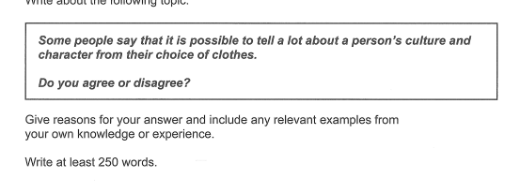

The Choice of Clothes

To some extent, someone’s clothes could reveal his or her character, but it is not always correct. As a matter of fact, after being designed, a clothe would be reproduced many times. It is presumptuous to say that everyone who buys the clothes has the same character. We should be aware of the genetic diversity of human beings. If someone’s wardrobe is full of various clothes, could you tell me which one could reveal his or her character which is determined by genes? Would it be presumptuous to judge a person only from these clothes?

A traditional costume is a symbol of culture, but you might only see them on a special occasion. Maybe a cultural fanatic is in costume every day and you can know what the person is, but you can not do that to someone who is in western clothes.

As far as I am concerned, I will choose the clothes which are pretty or cool and won’t waste time on the character or culture it reveals. Life is short, and it is psychologists or sociologists that should pay attention to the character and culture of the clothes. We just need to dress well.

**improved by Grammarly**

To some extent, a person's clothing can reveal their character, but it's not always accurate. In fact, clothing is often mass-produced, so it's presumptuous to assume that everyone who wears the same clothes has the same character. We need to be mindful of the genetic diversity among human beings. Even if someone has a diverse wardrobe, it's not fair to judge their character based only on their clothing.

While traditional costumes can be a symbol of culture, they are often reserved for special occasions. It's possible that someone who wears cultural attire every day is proud of their culture, but you can't make that assumption about someone who wears western clothing.

In my opinion, I choose clothes that I think are stylish or appealing, without worrying about what they reveal about my character or culture. Life is short, so psychologists and sociologists should focus on a person's character and culture, rather than their clothing. We just need to dress well.